# CHAPTER THREE

# METHODOLOGY

* 1. Concept

Robots are machines that are capable of carrying out complex series of tasks and actions. Robots come in various forms, shapes and designs. Some are humanoid, some are wheeled like cars, and others fly like drones. Their use in easing difficult tasks, especially in industrial settings, has become rampant recently. Consider robotic arms that aid in assembly, welding, machining to palletising and cleaning robots. This project focuses on using these existing technologies and implementing sensing, object mobility, autonomy, navigation, object stability, monitoring, communication and data logging to create a robotic system that is capable of autonomous navigation using obstacle detection, to detect heat anomalies in industrial motors and detect gas leakages as well to curb accidents related to such systems. Our robotic system uses Infrared thermography to detect heat anomalies and semiconductor gas sensors to detect gases. Below is a dive into each feature to be used, related technologies, and how they all come together to help us achieve our objectives.

* + 1. Movement

Our robot is a four-wheeled robot whose movements are aided by four high-torque DC motors. Due to the torque needed to move the payload in terms of battery and circuitry, geared motors were chosen as they offer the best performance in balancing torque and speed. Due to the terrain the robot may operate on, a suspension capable of allowing smooth operation even on uneven terrains was designed with an Inertial Measurement Unit and GPS to offer good localisation, heading and motion tracking.

* + 1. Sensing

With the objectives at hand, the bot needs to sense its surroundings during movement and for tracking leakages as intended. In that regard, ultrasonic sensors were the ultimate choice for obstacle avoidance to aid movement with the help of a camera system to enhance obstacle avoidance and mapping. Gas sensors were the optimal choice for leakage detection, with thermal cameras for localisation and for detecting heat anomalies in motors.

* + 1. Processing

To implement all our sensing and movement, there was a need for a central processor to process all the data being recorded by the sensors, which will aid in real-time decision making, autonomous navigation and object detection. A Raspberry Pi microcontroller was chosen as the main processor to implement artificial intelligence and autonomy, while an ESP32 microcontroller was chosen for processing sensor data.

* + 1. Communication

Our robot needs to be able to communicate with operators on the field and off the field; hence, a web app for live data monitoring, manual bot control and issuing alerts was to be developed. All sensor data is also logged online, with reports generated for tasks performed.

* + 1. Robotic System

The robotic system is our robot that combines all the features mentioned above to achieve autonomy, sense leakages and thermal anomalies in motors, log data onto a cloud and generate reports for future referencing and issue alerts upon anomaly detection while also accepting and implementing commands that will be issued using the web app during manual control.

* 1. Components

Components that combined efficiency and cost-effectiveness were selected for each feature of our system. These components were carefully selected by considering the requirements of our robot and choosing those that best fit our goal. The components and their roles in our robot are listed below.

* + 1. Chassis and Mobility

The basis of the working of any wheeled vehicle comes down to how durable its chassis is. Component selection is crucial to building a robust drive train capable of autonomy. The components used in this section are;

* Chassis (Fully Customised)

This is the entire frame of the bot on which all other components will be attached. This part will be fully custom-built to suit our needs.

* State-of-the-art tyres (Fully customised)

Since our bot is wheeled, there is a need for tyres able to carry the bot's weight and ease movement on terrains. Specialised tyres were designed for this purpose due to the unavailability of the required ones on the market.

* Motors

Motors are needed to drive our tyres. Due to the nature of the bot and payload, geared motors were selected and coupled to the tyres to drive them since they can produce the required torque for the bot’s movement. The motors to be used a 250rpm DC geared motors.

* Driver Circuit (L293D)

A driver circuit is needed to efficiently control the speed, direction, and torque of our motor. The motor driver used for this work is the L293D IC. The L293D is a quadruple high-current half H-Bridge for bidirectional drive current. This essentially allows for changing motor direction to aid in forward and backwards movement of the bot.

* Ultrasonic sensors

For our bot to be able to detect and avoid obstacles, there is a need for sensors that will aid in that activity. Ultrasonic sensors were more suited for this purpose due to their detection range. These sensors have both a transmitter that sends our high-frequency sound waves and a receiver that detects the received wave to measure the distance from an object and aid in its avoidance. The ultrasonic sensors to be used for this work are the HC-SR04.

* Camera

A camera is installed to further aid object detection and avoidance. It is also used to get visual feedback from the robot. Two ESP32 cameras will be employed for this work.

* GPS

This space-based radio-navigation system is used to aid in navigation and mapping of the plant by the robot. It also aids in knowing the exact location of the bot at all times.

* Power (Custom Built)

The main source of power for our bot will be a custom-made 12V battery pack comprised of Li – on batteries. This will serve to power all electronics through the use of voltage regulators and motors running the wheels of our bot.

* + 1. Sensors

This section covers the sensors that would be employed in detecting gas leakages and thermal anomalies in electric motors in the thermal plant. The sensors to be used are listed below:

* MQ-9

The MQ sensors are a series of gas detectors used for detecting various types of gases in the air. The MQ-9 was chosen for this project because it has a wider range that covers our intended use. It is highly sensitive to methane, carbon monoxide and a varied range of other flammable gases, of which natural gas is included. Since most thermal plants make use of natural gas, this sensor is ideal for gas leakage detection, and its range makes it easy for scalability up and other thermal plants that don’t use natural gas.

* MQ-135

With gas leakages come air quality issues. Thermal plants are known to be major emitters of gases that pose dangers to the environment. To check for such emissions, the MQ-135 sensors are employed. It is able to detect and measure the amount of harmful gases in the air for immediate strategies to be employed in managing such emissions.

* MLX90640 Thermal Camera

To detect thermal abnormalities, a thermal camera is required. This sensor detects infrared radiation in objects and converts it to visual images. This will be used to detect the changes in the heat of motors to indicate their condition.

* + 1. Processing & AI and User Interface & Communication

This comprises the main hub where all processing and communication between various parts of the bot and operators are going to be established.

* Processing & AI

All high-level processing required by the bot will originate from a Raspberry Pi microcontroller. Raspberry Pis are small, single board low-cost, versatile computers that are used in DIY projects and prototyping of large-scale projects. It is especially used in robotics and automation. For this project, the Raspberry Pi 5 was selected as it is cost-effective and also offers better processing performance than its predecessors. The Raspberry Pi will serve as the main processor that will accept data from the low-level processors in charge of processing data related to the various sensors and send feedback using that data. The low-level processors chosen for this project are the ESP32 microcontroller. It will serve as the basic processor that processes all things sensor-related and sends that data to the main microcontroller for further processing.

The microcontrollers will be embedded with AI that will be responsible for processing sensor data and sending feedback to ascertain the condition of motors, and also whether there are gas leakages. The AI algorithms will help with the identification of faults and possible fault conditions, and leakages from non-fault conditions and leakages.

* User Interface & Communication

We intend to provide a Human Machine Interface (HMI) through a web application that will allow for live feedback from the bot and also allow for manual override control should a need for such arise. The User Interface (UI) is intended to be simple to navigate and easy to get used to by anyone using the application, even for the first time. The app will also provide access to a cloud storage where data from the bot will be stored for future reference. All communication between the bot and the operators will be through the app, while alert systems will be installed for warning in case leaks and anomalies are detected.

* 1. Block Diagram

The block diagram below is a representation of the entire system and how each component communicates with the others. The block diagram includes all the components listed above.

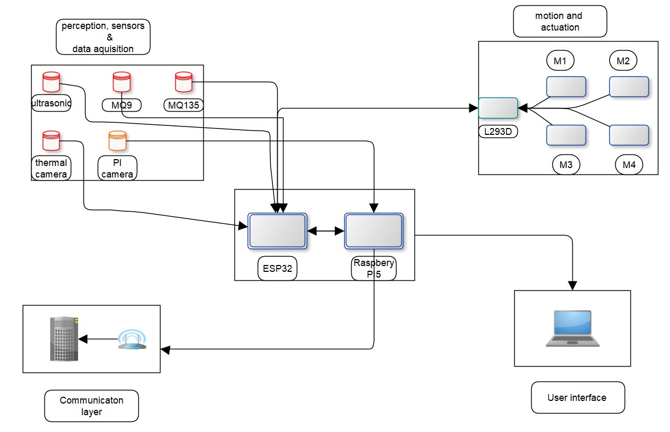

The entire working of the ground bot is divided into sections or blocks. They are: Perception, Sensors and Data Acquisition, Motion and Actuation, User Interface, Communication and Processing.

The perception, sensors, and data acquisition block represents all sensors within the system. This includes ultrasonic sensors, gas sensors, thermal camera and the Pi camera. These are responsible for communicating with the environment and sending feedback to the bot through the ESP32. The ESP32 then communicates with the Raspberry Pi to transmit the sensor data to the user interface or influence the behaviour of the bot. The motor and actuation block is responsible for the movement of the bot and communicates with the ultrasonic sensors through the ESP32. Sensor data from the ultrasonic sensors influences the movement of the bot and its path planning. It also uses the readings from the GPS to locate itself or move to specified locations. The user interface block represents the HMI section, where users interact with the bot and send commands or receive sensor information from the bot. In general, each block communicates with the centroid block, the processing block by sending and receiving commands or data.

* 1. Circuit Design

Below, we highlight the design concept of each block with its pin connections.

1. Ultrasonic Sensors

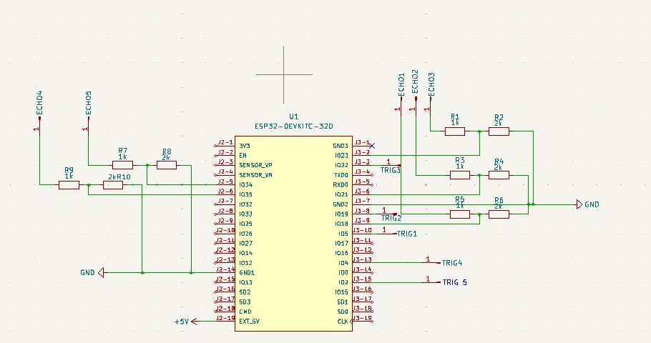

The image above depicts a typical ultrasonic sensor connection. The ultrasonic sensor has four terminals. Echo, Trig, VCC and Gnd. The VCC is the voltage input of the ultrasonic sensor, and the GND is its ground. The trig pin serves as the trigger to start the ranging, i.e. the emission of the ultrasound using a short 10us pulse so its echo can be raised. The echo has a pulse width and range in proportion for calculating the range through the time interval between sending the trigger signal and receiving the echo signal. Each pin is assigned to a specific General-Purpose Input/Output pin (GPIO) on the ESP32 microcontroller for transmission of the received signal for the microcontroller to process. To receive tolerable voltages from the ultrasonic sensors that would not pose any danger to the ESP32, a voltage divider is used to reduce the received signal to a base of 3.3V, the rated safe voltage of the ESP32.

1. MQ Sensors

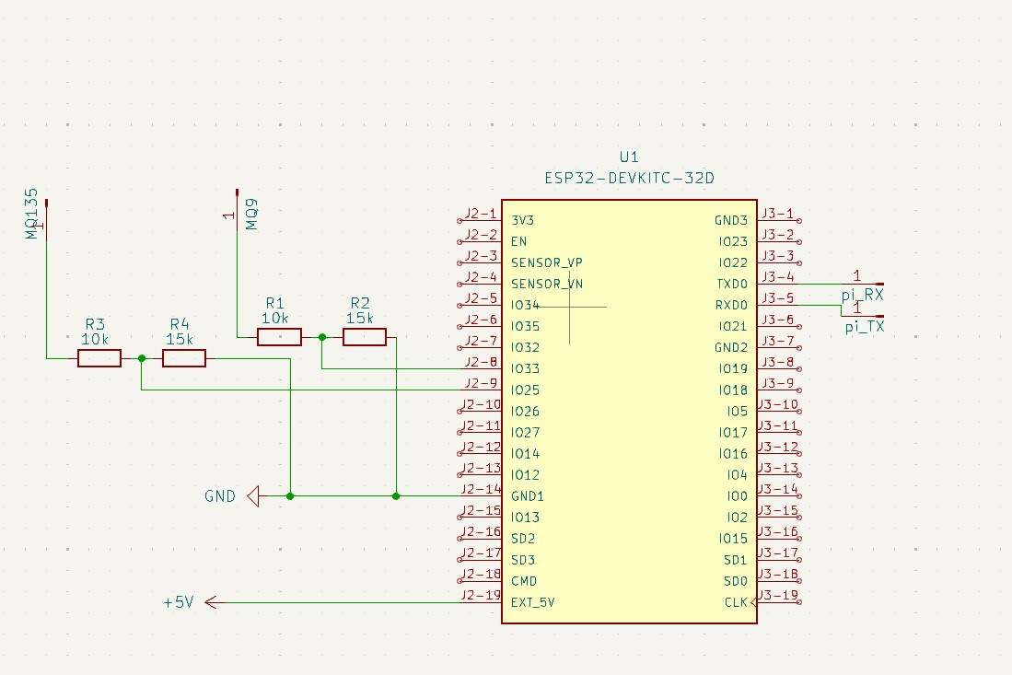

The MQ sensors are a type of gas sensor and have an in-built low conductivity material that, in clean air that increases its conductivity once the air is polluted by certain gases. This is the method used by the sensor to indicate the presence of gas in the air. A higher conductivity is an indication of a higher concentration of gas. The MQ sensors also have four pins. VCC, GND, AO, DO. Like the ultrasonic sensor, the VCC and GND are for voltage and ground, respectively. The Analogue Output (AO) is used to indicate a continuous rise in gas concentration, while the Digital Output (DO) is used to only indicate the presence of gas after it crosses a specified threshold.

1. Thermal Camera and GPS

The thermal camera is an Infra-Red (IR) sensor that detects heat changes within objects and displays them as a heatmap. The thermal camera has four main pins: VDD, GND, SDA and SCL. VDD and GND have their usual assignations. The SDA and SCL are used to establish serial communication between the sensor and the ESP32. The SDA is used to transmit serial data over I2C, while the SCL is the I2C serial clock for synchronisation. The GPS also has its power pins in addition to a TX pin for transmitting coordinates to the ESP32.

1. Motion and Actuation

Below is the circuit of the motor control. 4 geared DC motors are used and are driven by the L293D motor driver. The motor drivers have 8 pins. One can control two separate motors. Its pins are: VCC1, VCC2, 2 two-channel enables (EN), 4 inputs and Outputs, and 4 GNDs. VCC1 is used to drive the internal logic of the L293D with 5V, and VCC2 is used to drive the motors. Its inputs are paralleled and connected to the ESP32, and its outputs are connected to the motors.

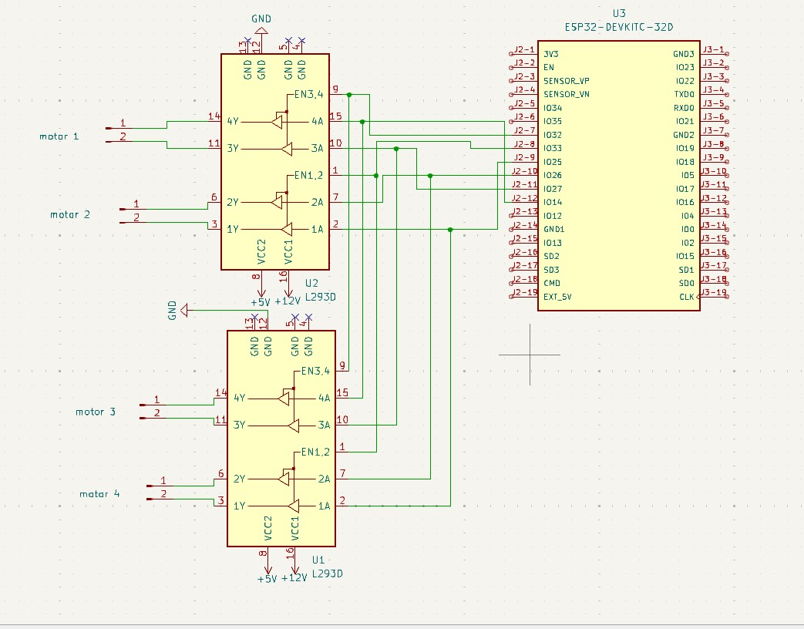

* 1. 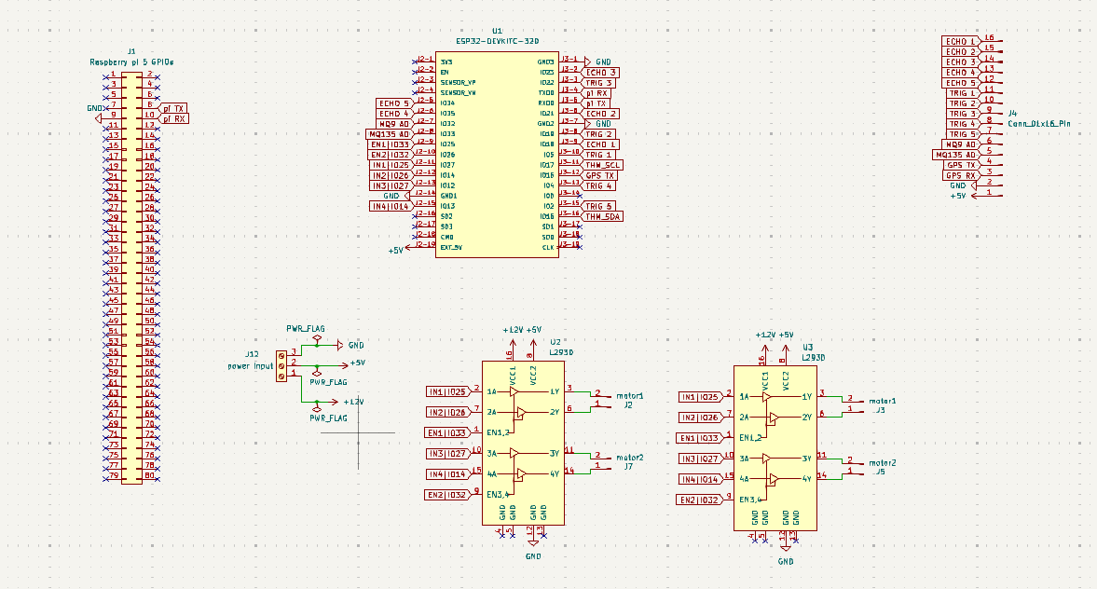System Circuit Design

This circuit encompasses all individual connections mentioned in the previous section. Labels are used instead of wire to prevent the circuit from being overcrowded. From the above circuit, all components are connected to specific GPIO pins, making sure there are no overlaps. Header pins represent some components, as they are the connection mode for the components. All unconnected pins on the ESP32 are FLASH pins and are unsuitable for achieving our objectives; hence are left unconnected. The ESP32 is connected to communicate with the Raspberry Pi through the TX and RX pins.